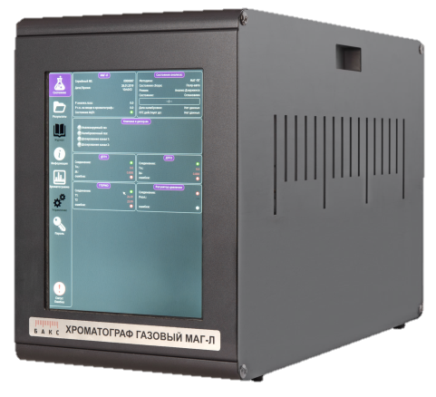

QUESTIONNAIRE LIST
for Gas Chromatograph analyzer
MAG
for laboratory purpose

General Information
Company |  | Date
Customer’s full name |  | Phone, e-mail
Questionnaire No. |  | Quantity
To get a technical and commercial proposal fill in this questionnaire and send it to NTF BACS LLC, e-mail: kom@bacs.ru or via fax #: (846) 932-05-71

Facility / Laboratory
Production or process
Purpose of analysis
(for instance, process control, commercial metering, etc.)

Composition of analyzed fluid
Item No. | Specify components | Specify detected components | Concentration |  |  | Units: % v, % mass, mg/m3, ppm
 |  |  | Min | Norm | Max
1 |  | ☐
2 |  | ☐
3 |  | ☐
4 |  | ☐
5 |  | ☐
6 |  | ☐
7 |  | ☐
8 |  | ☐
9 |  | ☐
10 |  | ☐
11 |  | ☐
12 |  | ☐

Analytical duration, minutes
Regulatory document for measurement method (GOST, STO, MI, RD, etc.)

Analyzed product properties
Number of analyzed samples
! This chromatograph can analyze u to 6 gaseous samples from various samplers connected to it, in alternate manner automatically.
If more than one sample is analyzed, specify temperature, pressure and components list for each sample.
Analyzed sample switching |  | ☐ automatic ☐ manual

Item No. | Parameter | Min | Norm | Max
1 | Sample operating pressure, MPa
2 | Sample temperature, °С
3 | Water dew point at operating pressure, °С (for gases)
4 | Boiling temperature, °С (for liquids)
Physical state of analyzed product
Solids (size, composition) |  |  |  |  | concentration, mg/m³
Stability: polymerization, decomposition etc.
Corrosive components (acids, sulfur compounds)
Approximate concentration of corrosive components, mg/m³

Chromatograph installation point
Location (fixed-site, mobile laboratory, other)
Temperature at chromatograph installation point, °С |  |  | Max |  |  | Min
Air humidity at installation point, no more than |  |  |  |  | %RH

Data transmission
Additional equipment | ☐ personal computer | ☐ laptop

Communication interfaces | ☐ Ethernet | ☐ RS232/485
 | ☐ Wi-Fi | Other:

Information display and input into chromatograph | ☐ Touchscreen LCD

Gas feed (available from the Customer)
☐ Instrumentation air pressure, MPa____________ ☐ Hydrogen
☐ Nitrogen ☐ Argon
☐ Helium ☐ Reference gas

SSRS (state standard reference sample) needed for calibration ☐ yes ☐ no

Additional information
Equipment and components supplied by Customer’s request
☐ Samplers |  |  | ☐ Pressure regulator for SSRS  ☐ Leak valve from SSRS cylinder  ☐ 40 l cylinders with carrier gas  ☐ Cylinder rack for carrier gas  ☐ Cylinder rack for calibration gas  ☐ Uninterrupted power supply
Type
Number, pcs.
Volume, l
☐ Pressure regulator for samplers
☐ Leak valve for samplers
☐ Microsyringes for liquid sample input
Number, pcs.
Volume, mcl

Specify if the following is necessary:
- commissioning operations ☐ yes ☐ no
- servicing personnel training ☐ yes ☐ no
- operational maintenance ☐ yes ☐ no
- measurement method development and certification ☐ yes ☐ no

SPTA needed | ☐ yes, for |  | years of operation | ☐ no

Other requirements:
Date |  | 20 | (year) | Signature |  | /
 |  |  |  |  |  |  | Full Name

