QUESTIONNAIRE LIST
MOISTURE CONTENT AND WATER
DEW POINT ANALYZER
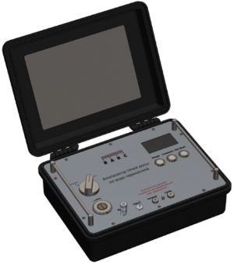
HYGROSCAN
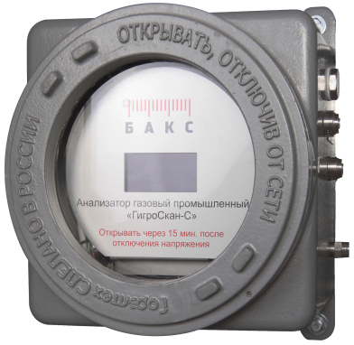
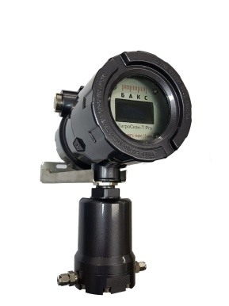

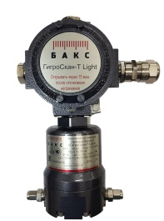
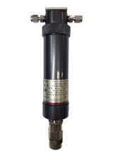

To get a technical and commercial proposal fill in this questionnaire and send it to NTF BACS LLC, e-mail: kom@bacs.ru or via fax: (846) 932-05-71
General Information
Company |  | Date
Customer’s full name |  | Phone, e-mail
Questionnaire No. |  | Quantity
- Required analyzer version:
select version
- Required amount of analyzers: ___
- Facility: _______
- Purpose of analysis: gas quality control, process control, etc.
_________________________________________________________________
- Measured parameters, ranges and measurement units
Measurement / calculation required | Parameter | Measurement range |  |  | Measurement unit
 |  | Min | Norm | Max
☐ | Water dew point temperature |  |  |  | °С
☐ | Water concentration in gas |  |  |  | mg/m3
☐ | Relative humidity |  |  |  | %RH
☐ | Other: _______ |  |  |  | specify
- Measurement result conversion to preset pressure: ☐ YES ☐ NO
If yes, specify the required pressure, MPa: ___
- Analyzed gas type: main pipeline gas, impulse gas, gas prepared for liquefaction, etc.
- Analyzed gas composition
Component | Concentration |  | Measurement unit | Component | Concentration |  | Measurement unit
 | Min | Max |  |  | Min | Max
H₂ |  |  | % mol. | N₂ |  |  | % mol.
СН₄ |  |  | % mol. | O₂ |  |  | % mol.
С₂Н₆ |  |  | % mol. | CO₂ |  |  | % mol.
С₃Н₈ |  |  | % mol. | H₂S |  |  | mg/m3
i-С₄Н₁₀ |  |  | % mol. | Mercaptans |  |  | mg/m3
n-С₄Н₁₀ |  |  | % mol. |  |  |  | select
i-С₅Н₁₂ |  |  | % mol. |  |  |  | select
n-С₅Н₁₂ |  |  | % mol. |  |  |  | select
С₆+ |  |  | % mol. |  |  |  | select
 |  |  | select |  |  |  | select
If other components are present in the gas, please specify them in the empty table cells.
- Solids in the gas ☐ YES fraction, composition ☐ NO, concentration: _____ мг/м3
- Liquid drops in the gas ☐ YES specify, which ☐ NO
- Methanol in the gas ☐ YES ☐ NO, concentration: _____ % мол.
- DEG or other glycol in gas ☐ YES specify, which ☐ NO, concentration: _____ % мол.
- Analyzed gas and ambient parameters
Parameter | Min | Norm | Max
Analyzed gas pressure at sampling point, MPa
Analyzed gas pressure at analyzer feed¹⁾, MPa
Water dew point, °С (at ___ MPa)
Hydrocarbon dew point, °С
(at ___ MPa)
Analyzed gas temperature, °С
Ambient temperature at sampling point, °С
Ambient temperature at installation site, °C
- To be filled in if measurements are performed at pressure different from operating gas pressure
Note: items 14-21 should be left empty for portable analyzer version, HygroScan-P.
- Analyzer operation mode: select mode
Note: with continuous operation mode analyzed gas continuously runs through analyzer at 0.5 – 2 nl/min flow rate.
  - Measurements frequency (for intermittent mode): 1 time per ___ Min
Note: with intermittent operation mode, the analyzer is equipped with an integrated or an external (for transmitters) electromagnetic valve to shut off the sample supply.
- Number of sampling points (for one analyzer): ___
Note: Stationary process analyzer HygroScan-S can perform alternate analysis on 2 streams of analyzed has with one device. HygroScan-T (transmitter) can analyze 1 stream of analyzed gas.

- Analyzer installation point: select from the list or enter manually
  - Cabinet or box to install analyzer needed:
☐ YES Description: specify main parameters if supply is needed ☐ NO
  - Ambient temperature at installation site:
from ___ °С to ___ °С.
- Sampler needed: ☐ YES ☐ NO
If a sampler is needed, please specify:
  - Pipeline material: _______
  - Pipeline diameter, mm: ___; wall thickness, mm ___
- Sampling line needed: ☐ YES ☐ NO
  - Heated sampling line: ☐ YES ☐ NO
  - Length of the sample feed lines from sampling point to analyzer, m: ___
  - Sample discharge line length, from analyzer to discharge point, м: ___
- Sample conditioning package needed (SCP): ☐ YES ☐ NO
- Cables and communication lines needed: ☐ YES ☐ NO
  - Distance from analyzer to electric switchboard (along the cabling line), m: ___
  - Distance from analyzer to communication line connection point, m: ___
- Data transmission method:
☐ RS232; ☐ RS485; ☐ Ethernet; ☐ 4-20 mA; ☐ Modbus; ☐ GSM; ☐ Other _______
- Additional equipment supplied with analyzer:
☐ Computer for remote control: select type
☐ Uninterrupted power supply
☐ Rack for analyzer
☐ Other _______

- Additional requirements: _______________________________________________________

Date ___ ____________ 20___ Signature ____________/______________________/

